Cruis'n with the
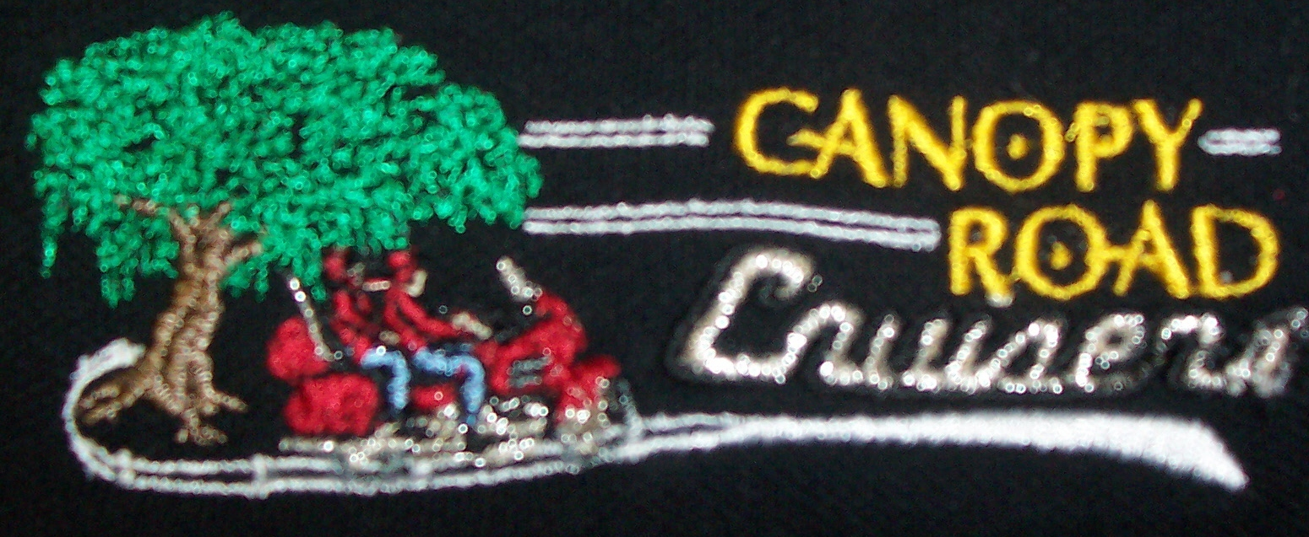
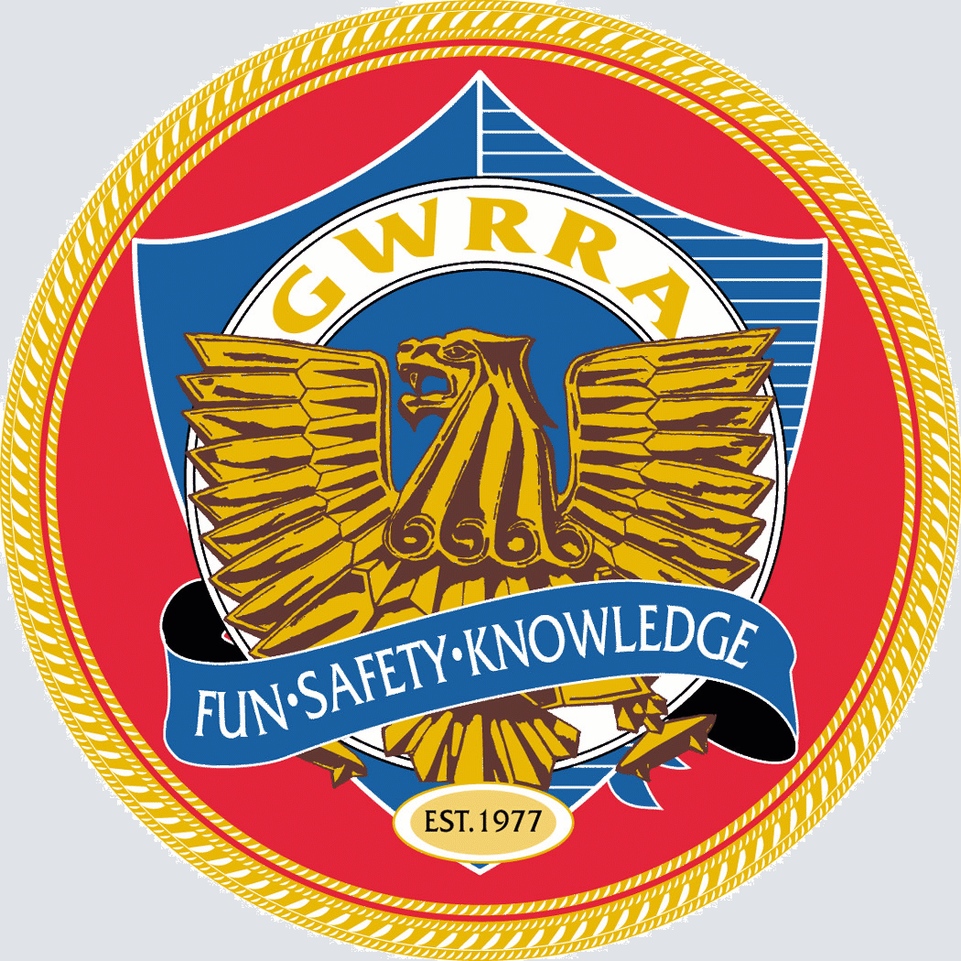 April 2011
NATIONAL,
REGIONAL &
DISTRICT
EXECUTIVE DIRECTOR:
Mike Stiger
REGION A DIRECTOR:
Bob & Nan Shrader
REGION A EDUCATORS
Chuck & Anne Reed
DISTRICT DIRECTOR:
Bill & Gina Berry
ASST. REGION A DISTRICT DIRECTOR: Ed Porter
ASST. DISTRICT DIRECTORS:
Nate & Danelle Kinion
Joe & Jan Mazza
Bill & Cheryl Smith
Geno & Kathie Jette
Bruce Griffing & Mary Haight
Cliff Hotchkiss—Harry & lynn Anderson
DISTRICT RIDER EDUCATOR:
Don & Judy Danbury
DIST. RIDETR ED ASST. ADMINST.
Mike & Bobby Roy
DISTRICT ADMIN ASSISTANT &
DIST. NEWSPAPER EDITOR
Millie Prince
DISTRICT WEBMASTER Howie Taylor
CHAPTER OF THE YEAR COORDINATOR:
Harry & Lynn Anderson
DISTRICT TRAINERS:
Rick & Madalena Buck
DISTRICT COY COORDINATOR:
Dennis Turcotte & Darla Williams
DISTRICT MAD COORDINATOR :
Nate & Danelle Kinion
DISTRICT TREASURER
Bill & Austine Barbour
Chapter FL1-A2 Tallahassee, Florida
We’re On the Net!
Visit our web site at
http://www.canopyroadcruisers.com

Send in your e-mail address to be
on the Chapter e-mail list!
leu3241@earthlink.net

Florida GWRRA Home Page Address
http://floridadistrict.com

CHAPTER STAFF

CHAPTER DIRECTOR:
Lenton & Leucretia Stephens
(850) 539-5084
ASST. CHAPTER DIRECTOR:
Open
8
TREASURER/SECRETARY:
Jo Nell Culverson

RIDE COORDINATOR:
Charles Couch
(850) 562-1399
RIDE COMMITTEE:
Charles Couch
(850) 562-1399
Sonny Rollo
(850) 559-1714
Mad Coordinator:
Rosalie Myers
(850)

NEWSLETTER EDITOR:
Leucretia Stephens
(850) 539-5084
PUBLIC RELATIONS:
George Walsh
(850) 539-1228
PHONE COORDINATORS:
Sonny Rollo
(850) 562-4293
George Walsh
(850) 539-1228
SUNSHINE LADY:
Carolyn Campbell
(850) 977-4901
WEBMASTER:
Karen Share
(850) 925-0345

Chapter FL1-A2 Information

General Membership Meeting
Second Thursday monthly
At
China Super Buffet
2698 North Monroe
Dinner at 6:30 pm
Meeting at 7:30 pm

Dinner Rides Every Third Thursday

We miss you when you’re not there!
Welcome to all visitors and new members!!!
We’re glad you’re with us!!!

TABLE OF CONTENTS
Anniversaries . . . . . . . . . . . . . . . . . 5
Birthdays . . . . . . . . . . . . . . . . . . . . 4
CD Goldline . . . . . . . . . . . . . . . . . . 2
Florida Events . . . . . . . . . . . . . . . . . 3
From the ADD . . . . . . . . . . . . . . . . . 3
Fun Report . . . . . . . . . . . . . . . . . . . .3
Kudos . . . . . . . . . . . . . . . . . . . . . . . 5
Local Dinner Rides . . . . . . . . . . . . . 3
New Bike Club . . . . . . . . . . . . . . . . . 5
Notes From Last Meeting . . . . . . . . .6
Region Events . . . . . . . . . . . . . . . . .
Safety Corner . . . . . . . . . . . . . . . . . 2
Welcome . . . . . . . . . .. . . . . . . . . .. . 5

Friends for Fun, Safety and Knowledge



Hi Fellow Gold Wing Lovers:

I can’t believe another month has gone by!
We had a grand time at the Florida District Rally in Kissimmee this month. We spent some time working with Nate & Danelle selling tickets. The talent show was a blast as always, vendors a plenty, Lighted bike show, bike show competition and lots of courses to attend!
The best part is always seeing old Wing Friends.
We had just over 1400 in attendance (or at least paid) which was up from last year!
Terry and Sylvia started out Wednesday and got as far as I-4 and had to return home because his new knee was hurting to bad to continue on to the Rally! As far as I know no one from our chapter attended.
Sorry to say no one I knew won the new Wing!

It’s spring time—time to ride---be sure to check out your ride for any problems, tires, brakes etc.

We learned Saturday that Greg Campbell was on the road to Valdosta when a very large oak fell across the road in front of him. It totaled his truck and put him in the hospital. Saturday he had plates put in his jaw, and had some intestinal bruising. He’s home, but will see another doctor tomorrow for his stomach.

I hope everyone escaped any property damages during the storm Monday night –Tuesday morning!
We had two very large oaks come down in the twisters Tuesday about 2:30am. They damaged another 6-8 trees on their way down.
If any one needs fire wood call me. We can fill a trailer for you. Larger pieces will need to be split and I don’t own a spliter! But if you want a lot of wood (mostly oak) you could rent a splitter and fill several trailers!

Also Rosalee Meyers had another back surgery and is home recovering. We sent both Greg and Rosalee Flowers from the Chapter!
See you all Thursday evening at the Chapter gathering ( Formerly Meeting).

Lenton & Leucretia Stephens

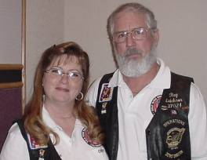
Region "A" Motorist Awareness Coordinators
Ray & Cindy Erickson
MAD@GWRRA-RegionA.org

Hi guys and gals! Hope this finds you getting in a lot of riding instead of fighting the flu bug and allergies. Cindy has had one bout with the allergies but so far I have been able to stay clear of it all. We have been able to make the Florida Convention and I a Chapter event (AL-U) in Dothan.

Earlier this month Carol Harrison (AL-M, CD) and I attended a local CMA meeting in Columbus, Ga. Also GA-G CD, Sam Fugart and other local bike clubs had officer-member representation on hand. Last but not least a senior member of the Patriot Guard spoke to us at this gathering. I was asked to speak and took the opportunity to talk to this group about “Motorist Awareness”. If you get the chance to make a CMA meeting near you, check it out. You will find a group of folks quite like ourselves who are fun loving good people who want the same things we do. Safe highways that we can all share safely.

Once again let me remind all you Coordinators that we are at the end of the first 2011-quarter. Reports are due by the 5th of April and I am aware this is a push but with this in mind do the best you can. Chapter Directors we need your help to get your Chapter reports to your District Coordinators ASAP! Please instruct your Chapter Coordinators that it is of the utmost importance that they file a N.23 Quarterly Motorist Awareness Report Form to be 401c4 compliant. You must do this even if you have nothing to report!

Ray & Cindy

*********

A.D.D. REPORT

From: Nate & Danelle Kinion

Ride safe.

TODAY IS A GIFT THAT’S WHY IT’S CALLED THE PRESENT

Fun Report

WING DING 33 “ Rollin On Rocky Top” in Knoxville, TN on July 6-9th , 2011
BE THERE!!

G W R R A News

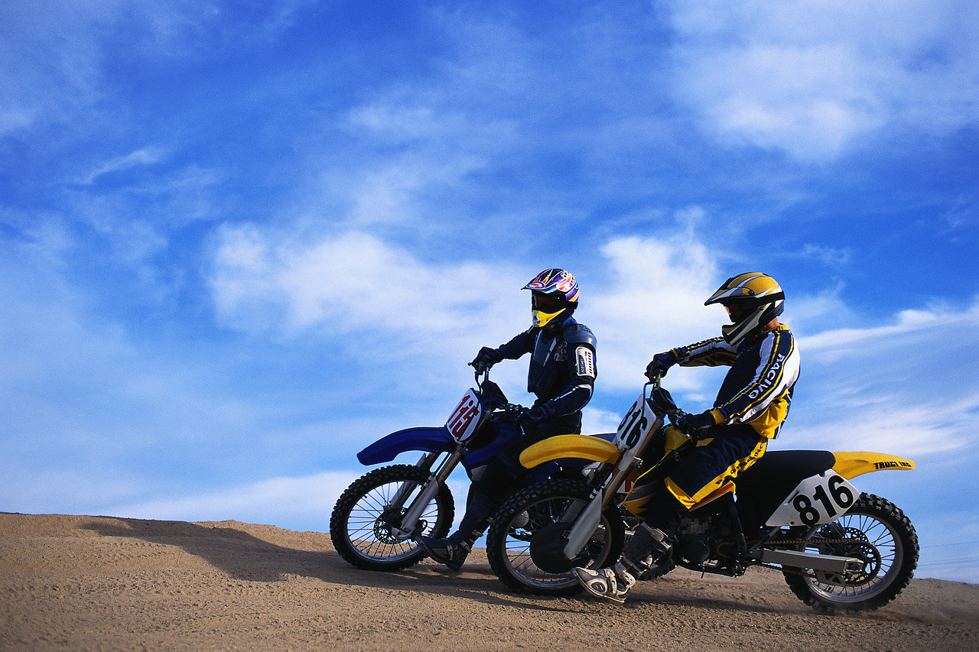

FLORIDA/GEORGIA/ALABAMA/MISSISSIPPI EVENTS

Apr 2 FL1-K Disabled American Veterans Poker Run Palm Coast FL
Apr 3 FL1-E2 American Diabetes Poker Run Ft Walton Beach FL
Apr 9 FL1-B Road Rally Seffner FL
Apr 9 Ride For Kids Jacksonville FL
Apr 16 FL1-W Green Eggs & Ham Orlando FL
April 28-30 South Carolina District Rally/Convention Charleston SC
May 4 FL1-F2 Chapter Rally Ocala FL
May 21-22 Horizon Program TBD
Jun 16-18 Georgia District Wing Fling Duluth GA
Jul 6-9 Wing Ding Knoxville TN
Aug 20-21 Officer Certification Program TBD
Sep 15-17 Region “A” Rally/Convention Eufaula AL
Oct 8 FL1-A Poker Run Tampa FL
Oct 13-15 Mississippi District Rally/Convention Tupelo MS
Oct 22-23 Horizon Program TBD
Oct 29 FL1-H2 Howl-O-Ween Harvest Picnic Orlando/Christmas FL

